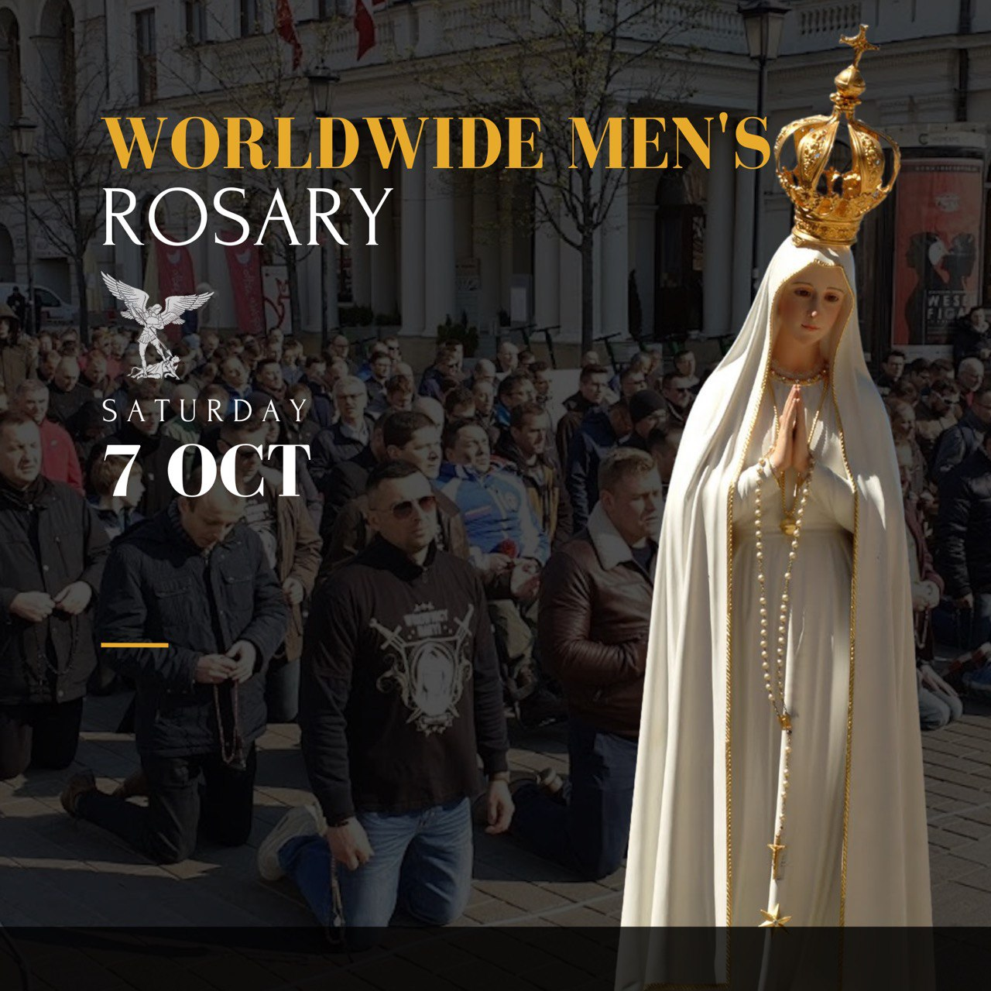

Time

Location Details

Mass & Confession Info

CITY Name

CRUSADE