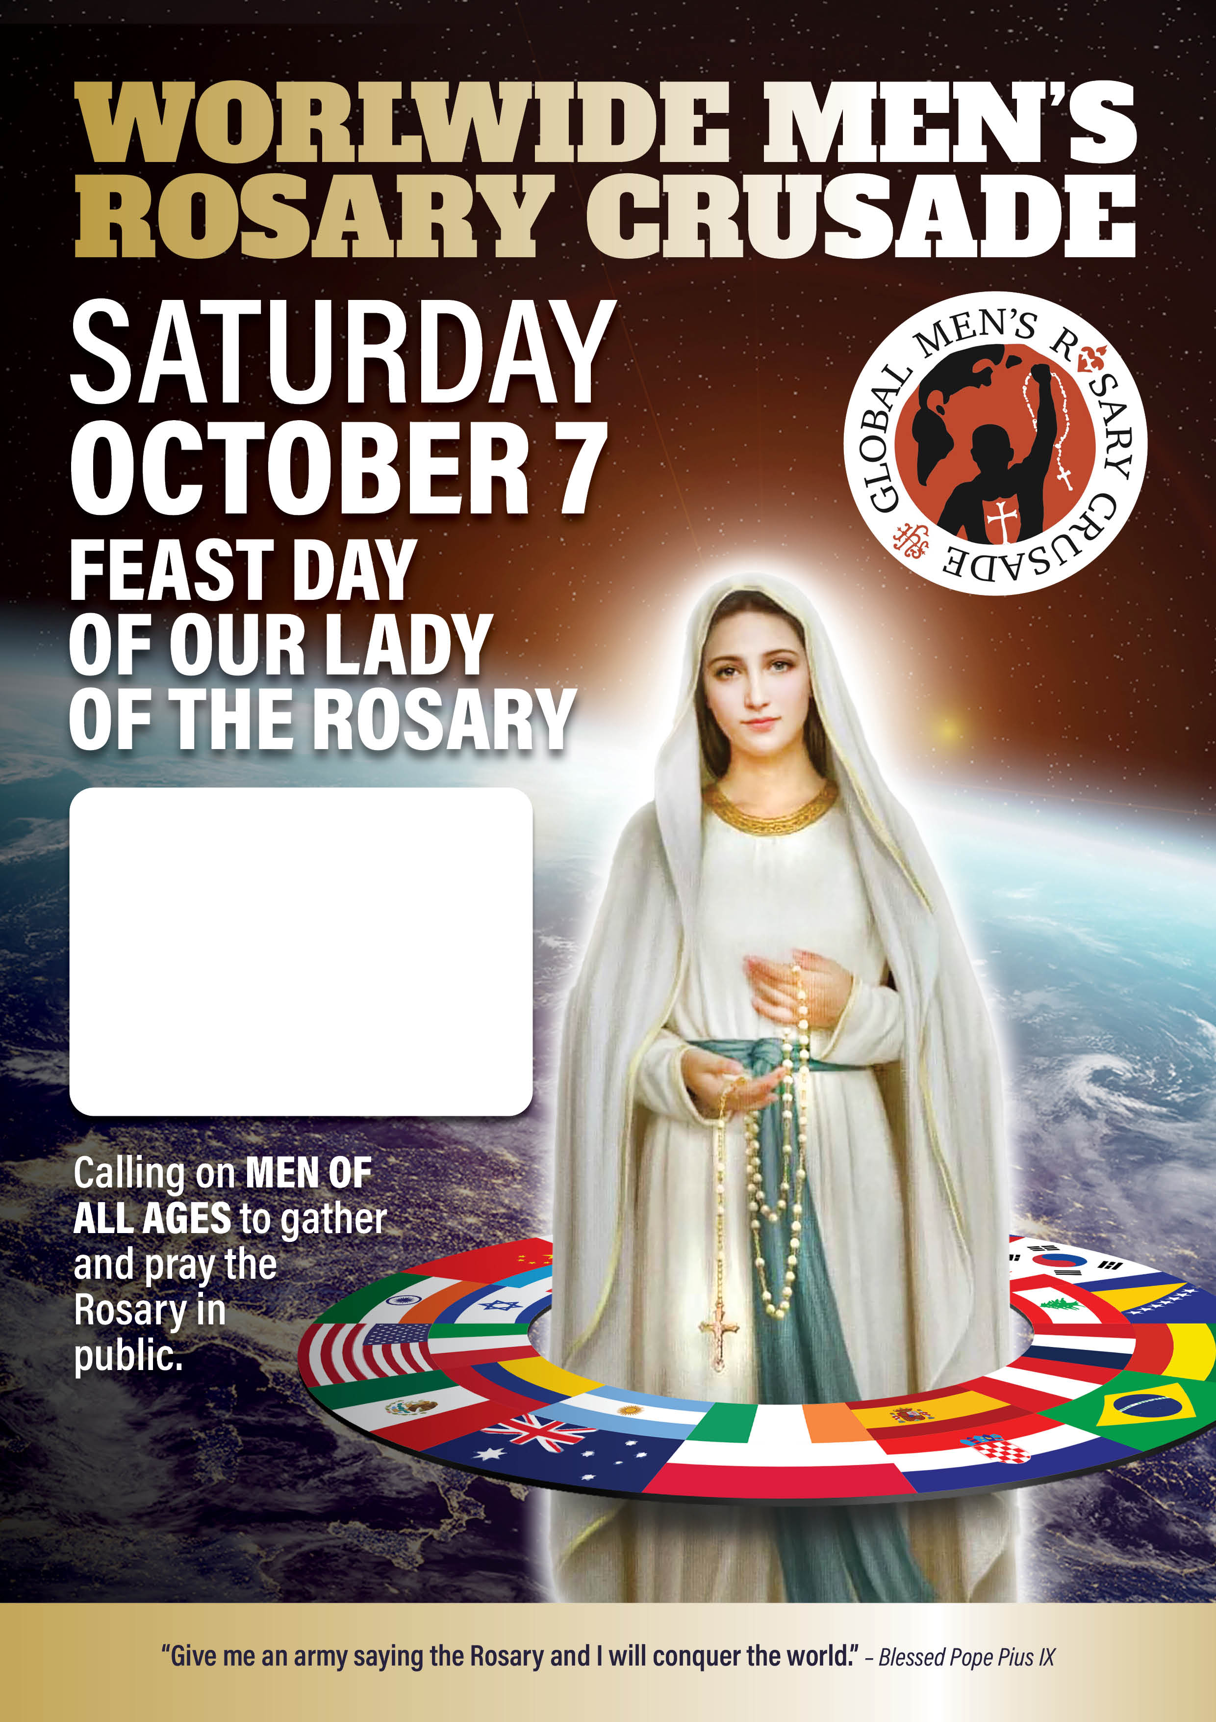

**1pm**

**St Mary’s Cathedral  
Forecourt**

Confessions available from

11am and Mass at

12pm in St Mary’s Cathedral